Git set up

What is Git ? – Git is a distributed version control system.

Git actually is a version control software

Github is a webservice

What is mean by distributed here? – distributed means every local computer has its own copy of project code and they will be working on their own local copy and then will push to remote.

With git, each local pc will maintain one local repository and whenever you commit the code it will be there in your local only but not in git repository until u push them.

Distributed ex: git  
Windows: Gitbash whereas for Ios and linux Git  
GUI tool: SourceTree

What is mean by centralized version control system.

Earlier days we followed centralised version control system means that we will be having a server in which we used to paste our code into it. If the server crashes we will be losing the whole data.

Centralised ex: subversion  
GUI tool: Tortoise SVN

In centralised there wont be any local repository. Whenever u commit or push the code will directly goes into remote repository.

Web based Repository providers

Github|  
GitLab  
Bitbucket

Whenever if we want to merge two different branches then we can create a pull request either in github,bitbucket then git will check those two branch changes and make us know with the conflicts for merge.

Once after resolve all the conflicts we can merge them.

First download git from google and install it

Sign up for github.

In github account, click create repository and give repository name to create new repository.  
Check in initialize repository with read me option  
Choose programming language and licence.

Actually we have 2 kind of repositories . one is GitHub and second is BitBucket.

Github is opensource where as BitBucket is a licenced version repository.

Open gitbash and proceed with below commands.

To Navigate to any folder - $ CD /C or $ CD /C:/Folders etc..

Then to go inside in that specific folder type command – cd Projects/

Note: First to enter main directory we have given forward slash first then folder name whereas to go inside the specific directory or folder first we mention the folder name followed with forward slash.(see red color above)

To clone the project – git clone git url(https://github.com/qmetry/qaf-blank-project-maven.git)  
so the command will be – git clone <https://github.com/qmetry/qaf-blank-project-maven.git>

To add files to git repository

Git add filename   
once done type git status to check what are the new files added.  
Then git commit –m “comments”  
ex: git commit –m “Changed testng-config file”  
Then to transfer file to git  
git push –u origin master

Now suppose you have done few changes in the existing files in your local repo and want to push them to git.

Then go to gitbash and type git status

It will highlight the file names which have the differences with git repo files.

Then add, commit and push those files to git repo by using the commands mentioned above.

--- some more info

**or create a new repository on the command line**

echo "# MyTestProject" >> README.md

git init

git add README.md

git commit -m "first commit"

git remote add origin https://github.com/parameshwarlu/MyTestProject.git

git push -u origin master

**…or push an existing repository from the command line**

git remote add origin https://github.com/parameshwarlu/MyTestProject.git

git push -u origin master

best video screenshots:

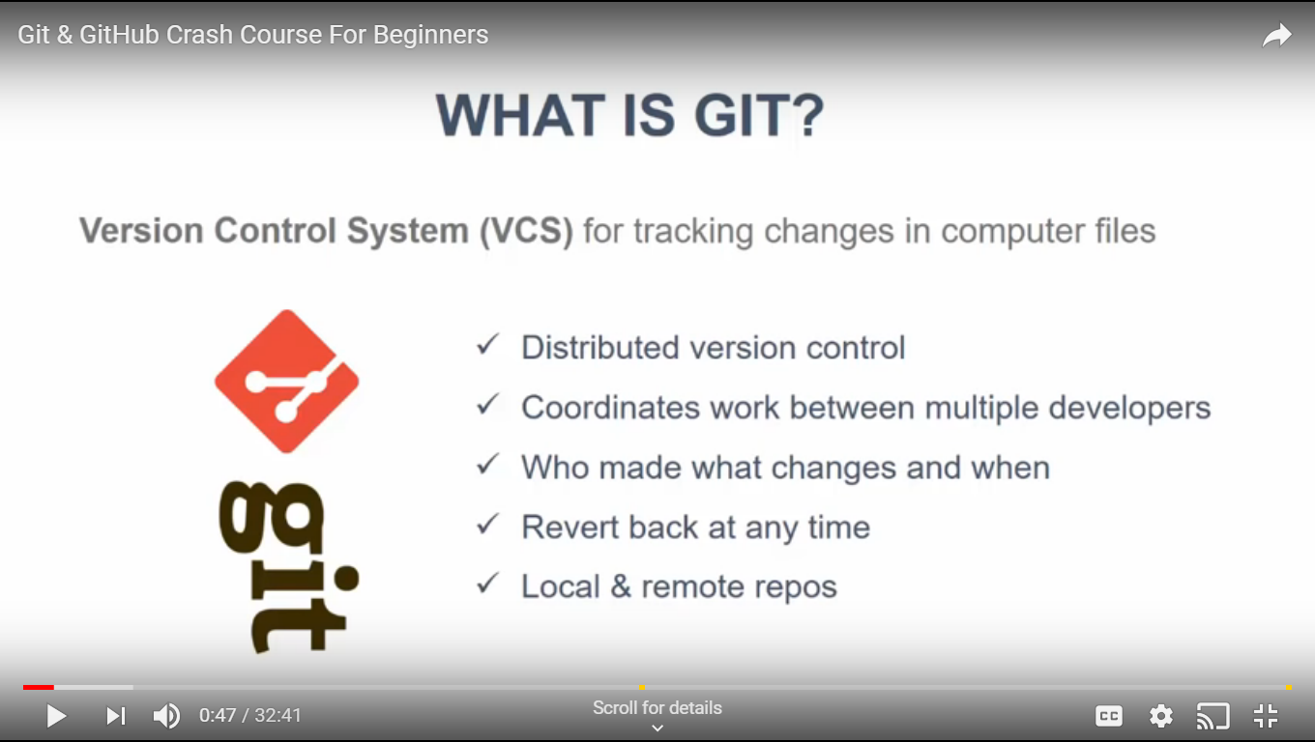

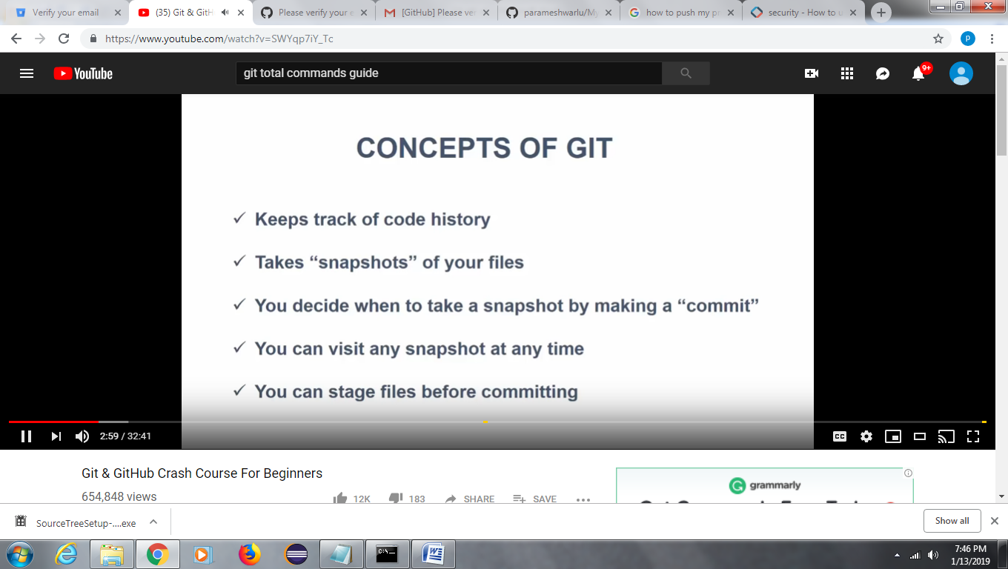

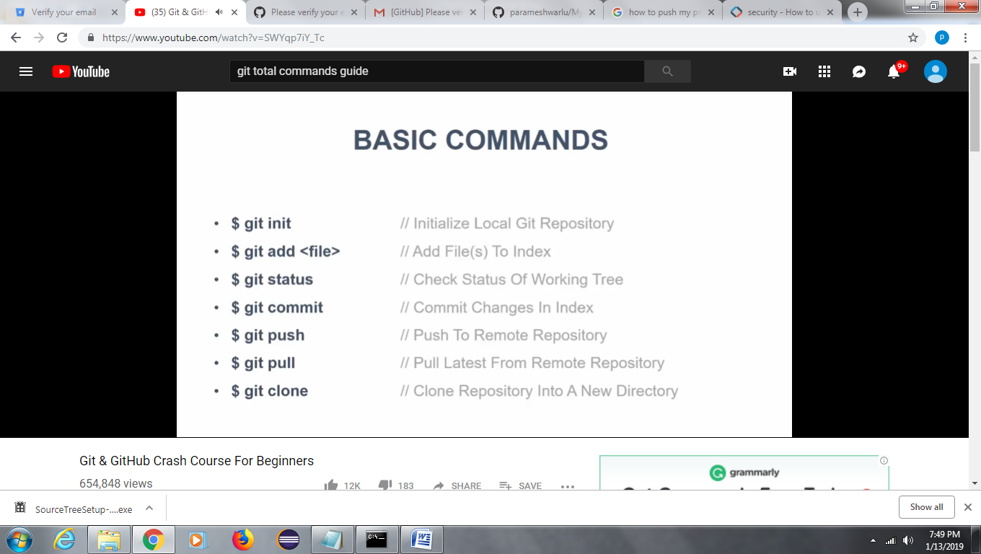

Also we have below:

Git –version

Note: we can use same commands from command promt or gitbash

If you want to create just any files from gitbash use below command

Touch index.html|  
touch pamy.java

What is fork in git ?

Suppose we are the project team. If someone wants to contribute to our project then first he can see our code with the project name serach in his git account. Then he can add his contribution code there and then will create a pull request so that, his changes will be appear to our project team. We can verify his changes and we can merge them with our code or else we can reject it. This is called forking.

Git command.

Pwd (gives the present working directory)

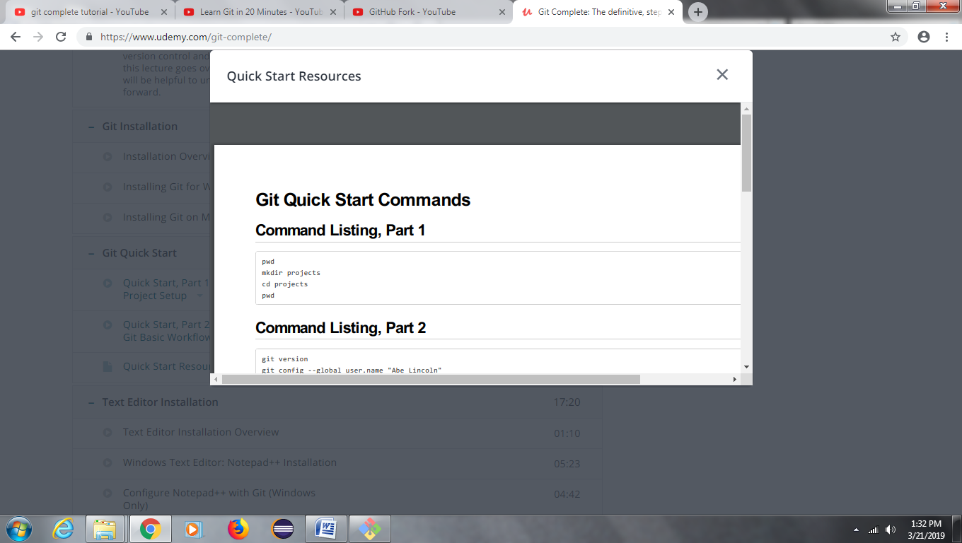

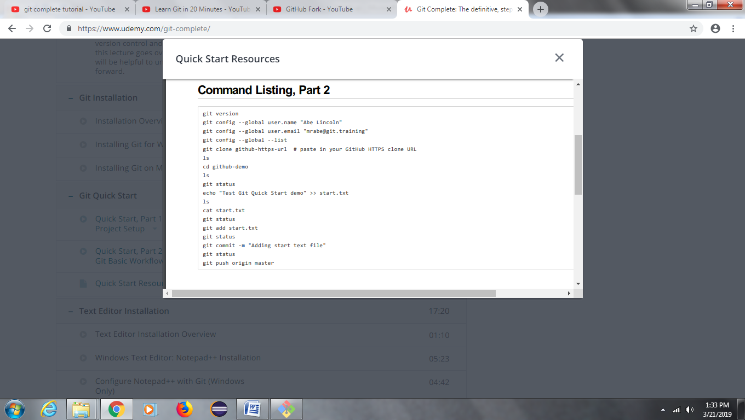

1. Git init??

Suppose you just have a fresh project in your local and you doesn’t created any repository in github.

Now you want to push this code to git repository assume.

So when you gitbash in your local project directory any type git status it says not a git repository. Means there is no local git repository created for this project.

Now type git init

It will create a empty local git repository for your local project.

Now type git status.

It says all your project files as unstaged bcs your local git repository is empty repository.

Now type git add .

This will add all your local files into your local git repository

Now type git commit –m “my first commit”

This will commit all your unstaged files into your local git repository.

Now try to push

Git push origin master

It will give a error saying fatal: origin doesn’t appear to be a git repository means that you doesn’t have a remote repository on github for this.

So go and create a git repository over github

Git remote (this gives the corresponding remote name) ex: origin

Git remote –v (this gives the remote repository name) ex: <https://github.com/rainbowcodeer/rainbow.git>

Now add a remote repository to your local repository

Git remote add origin (remote repo url)

Then try to push it will give below error

$ git commit -m "my first commit"

*** Please tell me who you are.

Run

git config --global user.email "you@example.com"

git config --global user.name "Your Name"

to set your account's default identity.

Omit --global to set the identity only in this repository.

fatal: unable to auto-detect email address (got 'HOME@HOME-PC.(none)')

so configure first.

Git push origin master

To pull

Git pull origin master

1. Branches and pull requests.

We can create branches to the master and then we can create a pull request from the branch to merge the code into master.

Pull request – take some changes from the particular branch and bring them into an other branch

If the conflicts there it will show and you have to fix those conflicts then merge.